# Step-by-step guide to install VOD ingest solution

# Revision History

|  |  |  |  |  |
| --- | --- | --- | --- | --- |
| Column 1 | Column 2 | Column 3 | Column 4 | Column 5 |
| **Version** | **Description** |  |  | **Release date** |
| v0.0.1 | Initial version |  |  | 07/19 |
|  |  |  |  |  |
|  |  |  |  |  |
|  |  |  |  |  |
|  |  |  |  |  |

# Description

VOD Ingest solution demonstrates how easily you can convert your source mezzanine video library into ABR, streamable contents. As easy as uploading your source video onto Amazon S3 bucket, the S3 event automatically triggers the ingest process, a state machine where:

* AWS Elemental MediaConvert is used to transcode the source file into MP4 formats with 6 different renditions (bitrates and resolutions) and stores the renditions in Amazon S3 bucket
* Amazon Lambda function then automatically creates a SMIL file to enumerate the rendition and ingest the MP4 renditions onto AWS Elemental MediaPackage VOD Package
* The new feature of AWS Elemental MediaPackage VOD Packaging reads the renditions from Amazon S3 and creates various streaming formats such as HLS, DASH, MSS, CMAF
* When the ingest is completed, Amazon SNS would then send a notification to the subscribed user and notifies the ingest status

The diagram below illustrates a high level ingest workflow.

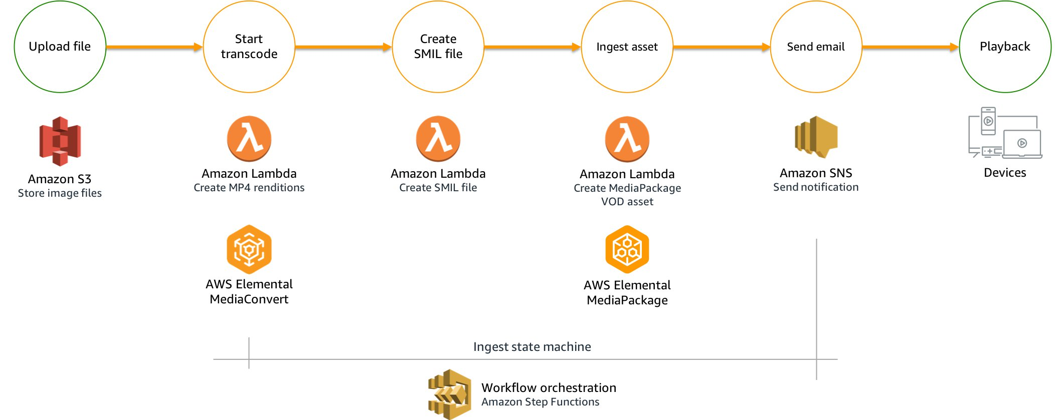

 The solution uses serverless architecture that means if you pay by the usage. It uses the following services:

* AWS Step Functions
* AWS Lambda
* Amazon SNS
* AWS Elemental MediaConvert
* AWS Elemental MediaPackage
* Amazon CloudFront
* Amazon CloudFormation

## Supported regions

* us-east-1
* us-west-1
* us-west-2
* sa-east-1
* eu-west-1
* eu-west-3
* eu-central-1
* ap-southeast-1
* ap-southeast-2
* ap-northeast-1
* ap-northeast-2
* ap-southeast-2
* ap-south-1

# Launching AWS CloudFormation stack

## Step 0: Log in to AWS Account

Go to AWS CloudFormation, select the intended region you would like to launch the solution

## Step 1: Specify template

Click on 'Create stack'. Under the Amazon S3 URL field, copy and paste the following url,

<https://mediaent-solution-eu-west-1.s3-eu-west-1.amazonaws.com/vod-ingest/v0.0.1/vod-ingest-deploy.template>

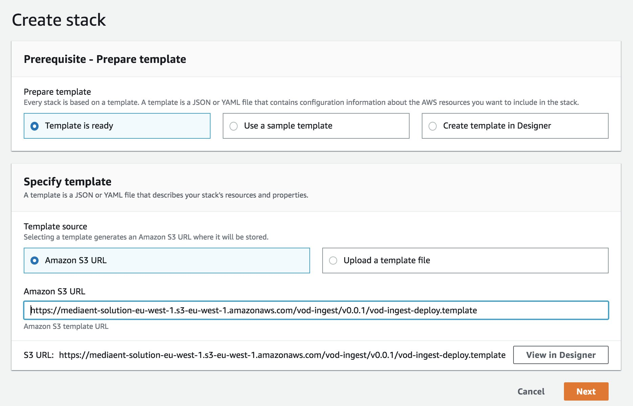

## Step 2: Specify stack details

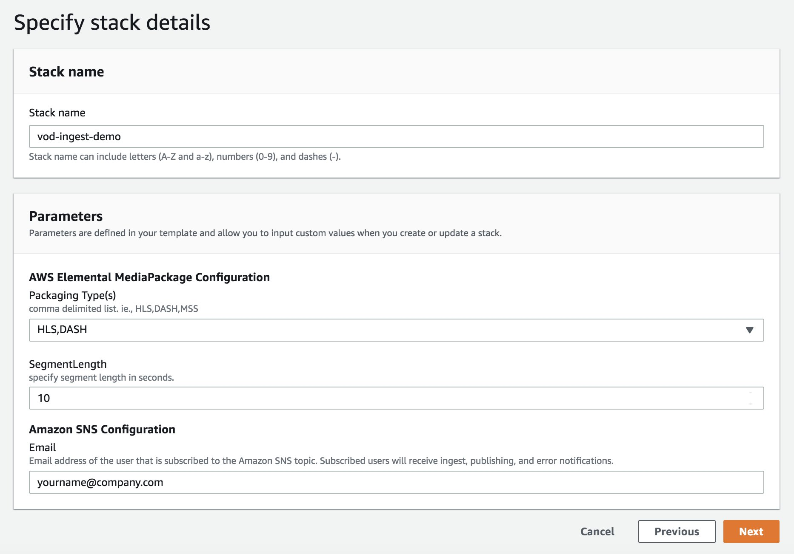

where

* **Stack name,**any valid string. It will be used to prefix the resources being created
* **Packaging Types,** can be HLS, DASH, MSS, and/or CMAF
* **Segment Length,**default to 10 seconds. You can specify between 2 to 600 seconds
* **Email**, to receive notification when the ingest is completed.

## Step 3: Configure stack options

Leave it as is and click on Next

## Step 4: Review

Before click on**Create stack**, make sure checkboxes under Capabilities section are CHECKED!

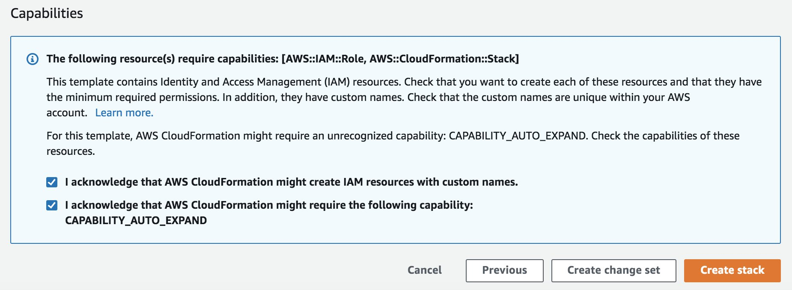

## Step 5: Gathering stack’s output information

Once the CloudFormat stack is completed, click on the **Outputs** tab, you should find many information.

The two parameters you would need to know are:

* **IngestBucket** is the bucket that you upload the original source files to.
* **ProxyBucket** is the bucket that stores the transcoded MP4 renditions.

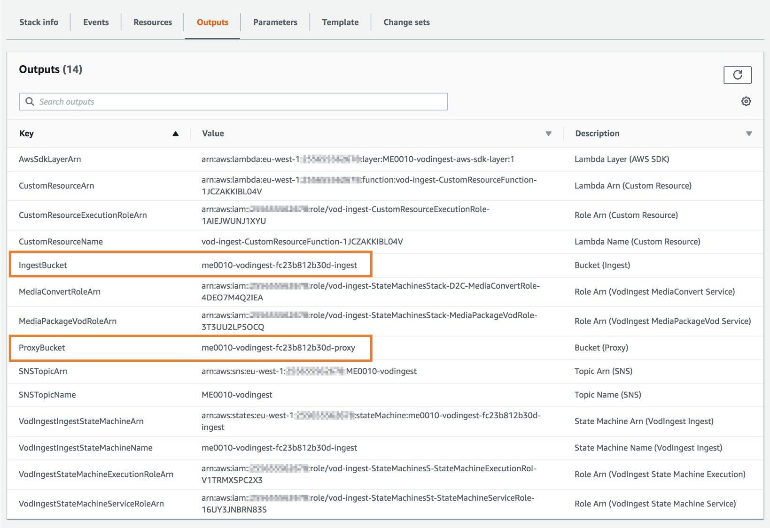

# Ingest content and get playback endpoints

To ingest content, simply upload a file to the **IngestBucket** either using AWS Console, AWS CLI, or AWS SDK. When the ingest process is completed, you will receive an email from our Amazon Simple Notification Service (SNS). The email contains the endpoint URLs as follows.

{  
  "operation": "job-completed",  
  "input": {  
    "src": {  
      "bucket": "me0010-vodingest-fc23b812b30d-ingest",  
      "key": "13309760.mp4"  
    },  
    "transcode": {  
      "jobId": "1563620145479-0cngol",  
      "destination": "vod/84e6299c01684780166b212c67e85b9c/13309760",  
      "renditions": [  
        "_1080.mp4",  
        "_720.mp4",  
        "_540.mp4",  
        "_432.mp4",  
        "_360.mp4",  
        "_272.mp4"  
      ]  
    },  
    "smil": {  
      "key": "vod/84e6299c01684780166b212c67e85b9c/13309760.smil"  
    },  
    "egress": {  
      "me0010-vodingest-fc23b812b30d-vod-package-mss": "https://be434bbaa90cae1ccdbdaf93e22989c9.egress.mediapackage-vod.eu-west-1.amazonaws.com/out/v1/178762be9ee24345b6d65af41e7e33ef/11cc74c729764b1fa3fc56a04e000ff8/5bfaebdca0e24d70aaaca92219945b13/index.ism/Manifest",  
      "me0010-vodingest-fc23b812b30d-vod-package-dash": "https://be434bbaa90cae1ccdbdaf93e22989c9.egress.mediapackage-vod.eu-west-1.amazonaws.com/out/v1/178762be9ee24345b6d65af41e7e33ef/0c7247d322734b56baf97b6eb108bfb3/a507ddc855a44bca9febdf85646fd4ca/index.mpd",  
      "me0010-vodingest-fc23b812b30d-vod-package-hls": "https://be434bbaa90cae1ccdbdaf93e22989c9.egress.mediapackage-vod.eu-west-1.amazonaws.com/out/v1/178762be9ee24345b6d65af41e7e33ef/6ddb1a2418fd48d897ab4e16b6475067/aaab0a7d955840258013968060289d88/index.m3u8",  
      "me0010-vodingest-fc23b812b30d-vod-package-cmaf": "https://be434bbaa90cae1ccdbdaf93e22989c9.egress.mediapackage-vod.eu-west-1.amazonaws.com/out/v1/178762be9ee24345b6d65af41e7e33ef/744f718578fa486d9a77ff6e25d33971/841012a4380f42aa866d9b83b49936c3/index.m3u8"  
    }  
  },  
  "progress": 0,  
  "uuid": "84e6299c01684780166b212c67e85b9c",  
  "status": "COMPLETED",  
  "tag": "StateMessage",  
  "stateMachine": "me0010-vodingest-fc23b812b30d-ingest"  
}

You can also find the information directly from AWS Elemental MediaPackage service.

Go to **MediaPackage > Packaging groups**, click on the packaging group created by the stack.

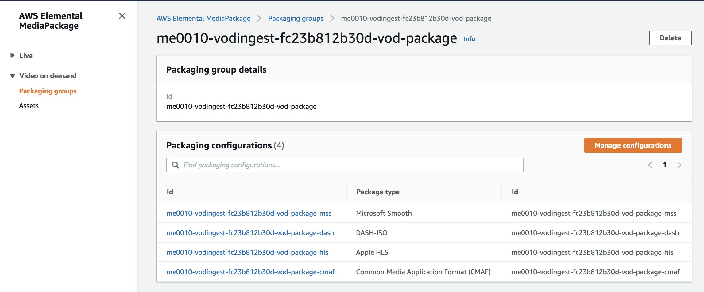

# APPENDIX A: Supported input file formats

The solution template registers S3 event (s3:ObjectCreated) on the IngestBucket to trigger the ingest workflow. The supported file extensions are:

* .mp4
* .mov
* .wmv
* .mxf
* .ts
* .mpg
* .mpeg

# APPENDIX B: Ingest state machine

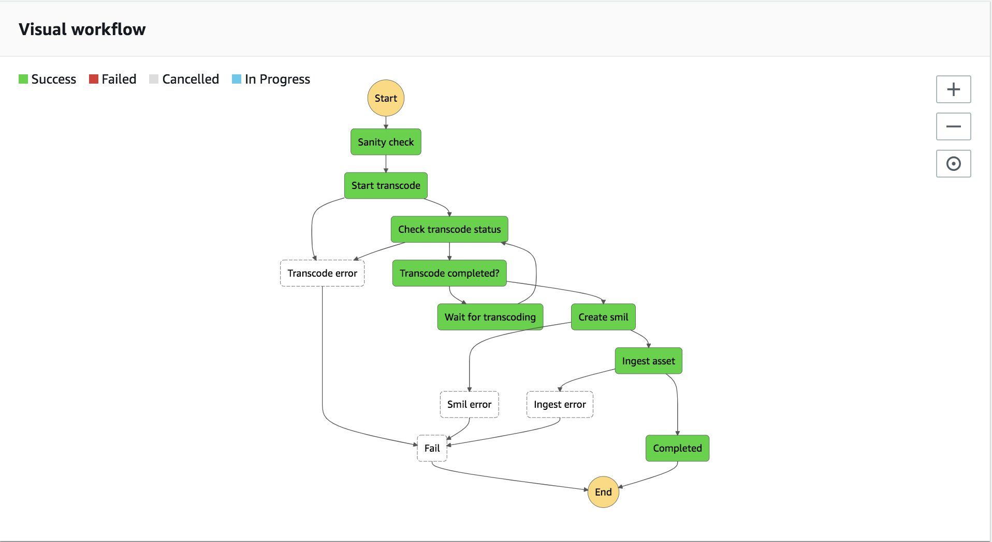

That’s all!